# 30 June 2016

**Miling of Chromium coated SiN membrane.  
Piercing through the membrane with different doses**

**11:30**

**Parameters :**

|  |  |
| --- | --- |
| Coating | 5 nm Cr |
| Thickness | 5 + 100 nm |
| Beam | 35kV 20µm (8) 6.0pA |
| Measured current | 6.75 then 6.97 pA |
| Loop Factor | 20 |
| Line Dose | 1000 then 3000 µC/cm |
| Dot dose | 0.10044 then 0.8 pC |
|  |  |
| Design | *Multiple fall* |
| Design Dose factor | *1* |

**Experience and Results:**

Left: Line dose 1000 and Dot dose 0.10044  
Right: Line dose 3000 and Dot dose 0.8  
From left to right: dose factor 1 to 1.8 (step: 0.2)

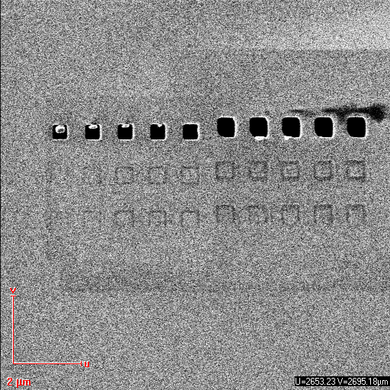

A dose of 20*0.10044*1=**2.0088pC** is enough to pierce through the membrane with dots. For low doses a part of the membrane seems to hold on to a border:  
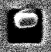

Concerning lines, a dose of 1.8*20*3000µC*0.0032=**345.6µC** is not enough to pierce through the membrane.

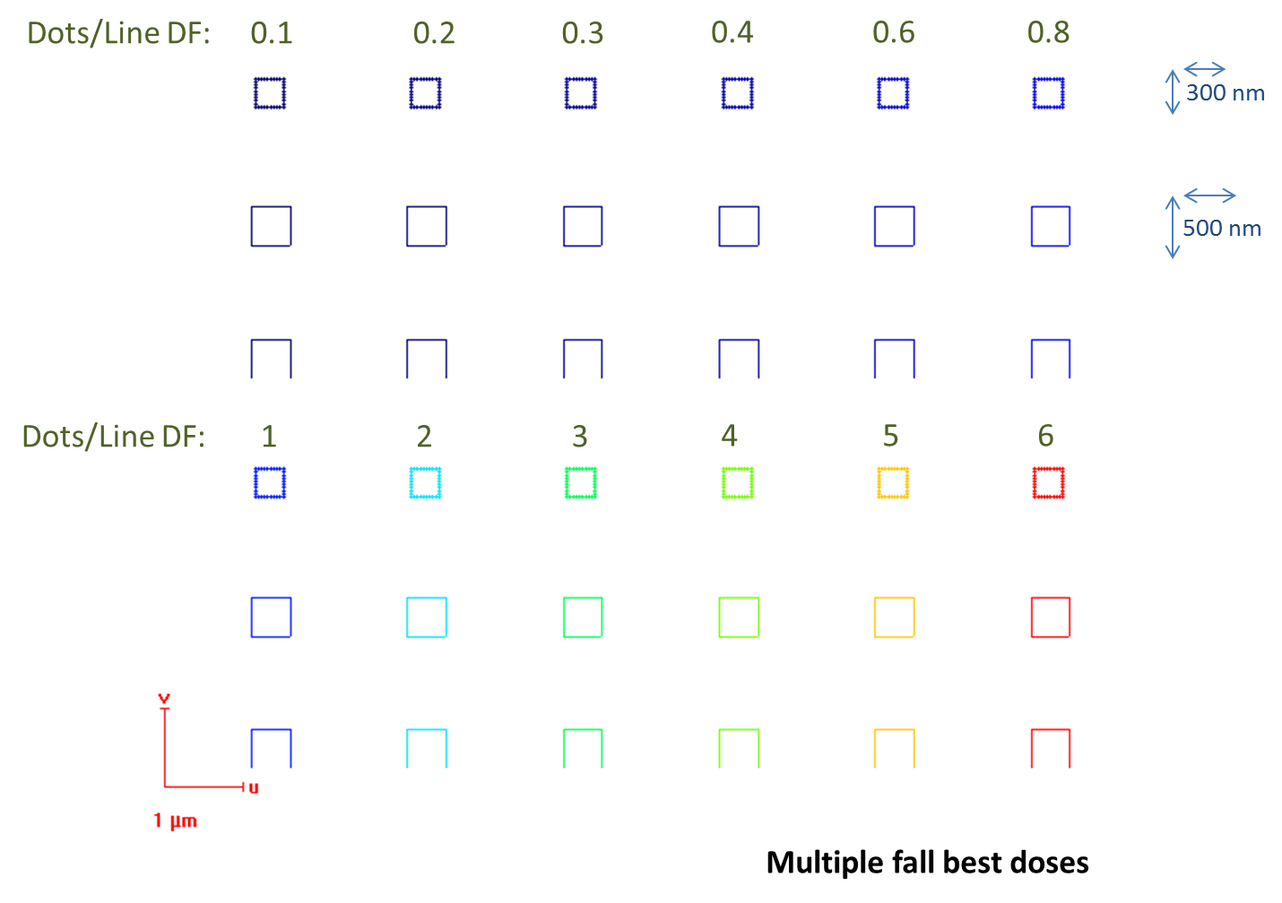***To bring forward the importance of doses, we will use a new design:*** *multiplefall-bestdoses* ***composed of dose factors: 0.1; 0.2; 0.3; 0.4; 0.6; 0.8 on a first line, and 1 to 6 on a second line:***

**12:15**

**Parameters :**

|  |  |
| --- | --- |
| Coating | 5 nm Cr |
| Thickness | 5 + 100 nm |
| Beam | 35kV 20µm (8) 6.0pA |
| Measured current | 6.83 pA |
| Loop Factor | 20 |
| Line Dose | 1000 µC/cm |
| Dot dose | 0.1 pC |
|  |  |
| Design | *Multiple fall* |
| Design Dose factor | *1* |

**Experience and Results:**

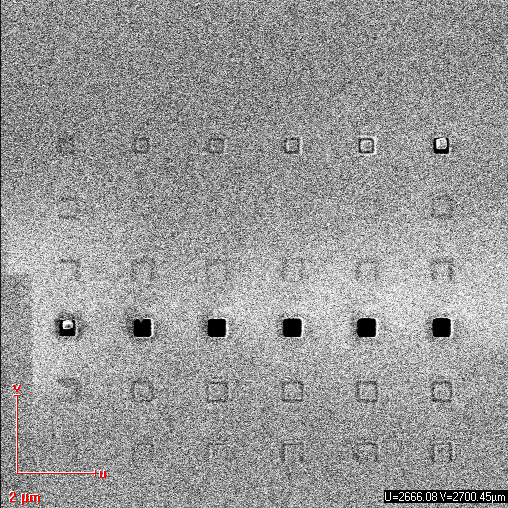

The dot at dose factor 0.6 does not pierce the membrane, contrarily to the dot at 0.8:  
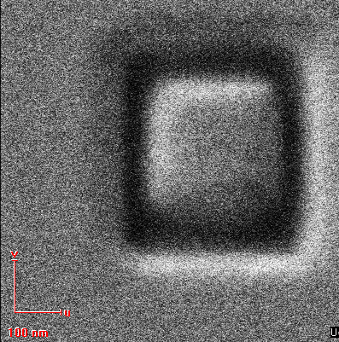 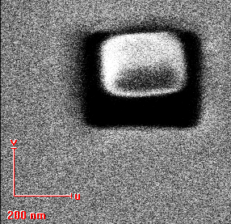

Therefore, the limit dot dose to pierce through the membrane is supposed to be between 20*0.1*0.6=**1.2pC** and **1.6pC.** Moreover a line dose of 20*1000*6*0.0032=**384µC** is not enough.